
J. Environ. Treat. Tech. ISSN: 2309-1185



Journal web link: http://www.jett.dormaj.com

Environmental Impact of Scrap Metal Dumpsites on Vegetation, Soil and Groundwater in Yenagoa Metropolis, Nigeria

Tariwari C .N. Angaye^{1*}, Woyengidoubara W.T. Angaye², Godbless N. Oyinke², Odigo Konmeze³

1- Ecotoxicology Research Unit, Department of Biological Sciences, Niger Delta University, Wilberforce Island, Bayelsa State, Nigeria.
2- Department of Family Medicine, Niger Delta University, Wilberforce Island, Bayelsa State, Nigeria.
3- Department of Environmental Management, Imo State University, Nigeria.

Received: 15/03/2016 Accepted: 18/03/2016 Published: 30/09/2016

Abstract
The environment is an intrinsic resource that sustains man and all living organisms for growth, and survival. As such the protection of the environment against adverse impacts must be sustained. This study assessed the impacts of scrap metal dumping on soil, water and vegetation in Yenagoa metropolis. Soil, groundwater and vegetation samples were randomly collected from scrap metal dumpsites in Yenagoa Metropolis. The samples were similarly analyzed for Heavy metals using standard analytical methods. Results of soil quality for surface (0-15cm) and subsoil (15-30cm) were 12.27 – 74.27 and 6.21 – 52.13 mg/kg respectively (iron), 7.24 – 35.73 and 11.41 – 33.57 mg/kg (copper), 14.23 – 47.17 and 12.11 – 36.22 mg/kg (manganese), 11.07 – 49.38 and 17.42 – 35.72 mg/kg (zinc), 24.43 – 47.67 and 17.11 – 32.38 mg/kg (aluminum), 11.48 – 35.77 and 9.53 – 31.22 mg/kg for Nickel. For water quality, the pH ranged from 4.62 – 6.33. While the level of iron, copper, manganese, zinc, aluminum and nickel ranged from 3.27 – 9.73, 0.0152 – 0.071, 0.0023 – 0.0023, 0.0022 – 0.523, 0.0023 -0.0023 and 0.005 – 0.005 mg/l respectively. On the other hand, concentrations of manganese, aluminum and nickel recorded were below detection limit. For vegetation, Iron, copper and zinc ranged from 0.338 – 3.027 mg/kg, 0.0152 – 0.1071 mg/kg and 0.0023 – 0.223 mg/kg respectively. While, manganese, aluminum and nickel were not detected. Based on the findings of this research, it is recommended that scrap metal dumping in Yenagoa metropolis should be subjected to periodic monitoring.

Key words: Impacts, Scrap metal, Bayelsa state, Mitigation, Solid waste.

1 Introduction
Metal, being a solid waste is seen as any unwanted, superfluous material that is not liquid or gaseous product or anything discarded after production [1]. George et al., [2] suggested that most solid waste is has no economic value to the producer, indicating that most solid waste could become irrelevant depending on its recyclability. In every human activity waste is continuously generated [3], as such waste production has become an inevitable aspect of our daily life. Notwithstanding, the challenges associated with waste management is becoming a source of global concern. Although robust waste management policies are being fully implemented in developed countries [4], but unfortunately some developing countries are still challenged with poor and inappropriate waste management methods, due to inadequate waste management facilities and weak legislation [5].
Angaye et al., [5] reported that the type of wastes generated is dependent on the activities being carried out, as well as the population and size of the sector. Scrap metals are pieces of metal parts that can be recycled such as auto parts, used wire and metals from manufacturing and assembling operations, which constitute a great percentage of solid waste in Yenagoa metropolis. Scrap metals scavenging has become a mainstay in Yenagoa due to its recyclability and thus economic intricacy. Scrap metals are major constituents of the municipal solid wastes (MSW). It accounts for about 1.8% in South West [6], 10.8% in South East [7] and 3 – 20% North Western [8].
Scrap metal is a complex and waste which are recalcitrant to degradation. The Leachability of heavy metals from scrap metal dumpsites into the soil, could contaminate ground water [5].
Generally in Yenagoa metropolis and other similar cities, there is a marked imbalance between waste generation and waste control/disposal, this is because a clear priority has often been given to the matters of commercial and industrial development without paying equal attention to the development of waste management facilities [9]. The increasing level of waste generation in developing nation has become a global source in most urban areas. This is compounded by the high rate of population growth and increasing per capital income, as well as industrialization. Notwithstanding, the consistent dumping of these metals prior to their marketing and transportation may leach contaminants to impair the ecosystem [5, 10].
The generation of solid waste such as scrap metals is posing serious threats to quality of soil, vegetation and groundwater. These threats are even more in developing countries with inadequate litigable and legislative measures, where large quantity of solid waste are haphazardly dumped, without robust contingency planning, thereby infringing on the quality of certain sensitive environmental resources such as air, soil, water and vegetation [5].
While many Nigerian researchers have worked on the effects, characterization and management of solid waste in general [2, 3, 11 - 13], little attention has been given to the impact of scrap metal dumpsites on vegetation, soil and groundwater. There are three basic streams of wastes (i.e. liquid, solid and gaseous waste), discharged into the environment on daily basis but solid wastes (especially metals), constitute higher nuisance due to the fact that it is recalcitrant to degradation, occupy space and prone to emit toxic leachates to the environment [5]. Therefore this study has become necessary to assess the impacts of scrap metals and their effects on vegetation, soil and groundwater.

2 Materials and Methods
2.1 Area of Study
The study area is Yenagoa Metropolis, the capital of Bayelsa State, which lies south of Orashi River in the Niger Delta Region. It is located on latitude 4⁰ 49N and 5⁰ 23’N and longitude 6⁰ 10’E and 6⁰ 33’E with a population estimate of over 300,000 [14], since attaining the status of a state capital in 1996 construction and other commercial activities have accelerated appreciably. The study was conducted in randomly selected scrap metal dumpsites in Yenagoa metropolis.

2.2 Research design
Table 1: Sampling point with their respective coordinates
Sampling  Locations | Direction (Elevation) | Coordinates |  | Site Age
Sampling  Locations | Direction (Elevation) | Latitude | Longitude | Site Age
Etegwe (A) | SE (44Ft) | N04⁰57’0.51” | E006⁰21’10.1” | 7yrs
Biogbolo (B) | SW (32Ft) | N04⁰56’0.22” | E006⁰19’48.8” | 8yrs
Swali 1 (C) | NE (33Ft) | N04⁰55’35.6” | E006⁰16’38.9” | 5yrs
Swali 2  (D) | NE (34Ft) | N04⁰55’29.6” | E006⁰16’33.9” | 5yrs
Okutukutu (E) | SW (19Ft) | N04⁰57’0.51” | E006⁰21’10.1” | 5yrs

Table 2: Experimental design for sampling of soil, water and vegetation samples
Points | Sample codes |  |  | Predominant  Vegetation
Points | Water | Soil | Vegetation | Predominant  Vegetation
A | WA | SA | VA | Siam weed
B | WB | SB | VB | Cocoa Yam
C | WC | SC | VC | Bitter Leaf
D | WD | SD | VD | Mango
E | WE | SE | VE | Plantain
Control | XW | XS | XV | Pawpaw

2.3 Sampling Techniques
2.3.1 Soil sampling
Six soil samples including one control were collect from scrap metal dump sites in Yenagoa metropolis Bayelsa state, Nigeria. The scrap metal dump sites were located at Etegwe, Biogbolo, Okutukutu and two in Swali. The soil was collected in range of two depths i.e top soil samples (0 - 15cm depth) and sub soil sample (15 - 30 cm). Soil hand auger was used for sample collection. The composite sampling was carried out. The soil samples were collected on the different locations with sterile Ziploc bags. The samples were then transported to the laboratory for analysis.

2.3.2 Water sampling
Similarly, water samples were collected from boreholes close to the site of scrap metal dumpsites. The water samples were collected in a sterile 1 litre bottle container. And on site, the pH of the water was determined using pH meter with probe (HANNA HI9820).

2.3.3 Vegetation sampling
Dominant plants species were collected within and around the sample sites as presented in Table 2. A total of Five (5), plant were collected from the sample sites namely siam weed (Chromolaena odorata), mango (Magnifera indica), pawpaw (Carica papaya), plantain (Musa pardisiaca), and bitter leaf (Veronia amygdalina).

2.4 Techniques for Data Analysis
Physicochemical analysis: unstable parameters such as pH on the field is discussed below.

2.4.1 Determination of pH
The pH was determined insitu by the method described by Ademoroti [15] using pH meter (HANNA HI 9820). The pH electrode was first calibrated at pH 4, 7 and 10 with pH buffers and stabilized in diluted water. The calibrated electrode was then dipped in soil samples. The pH reading were taken when a stable reading was obtained.

2.4.2 Techniques for Heavy Metal Analysis
The digestion method previously described by Abidemi [16] was employed for soil analysis. About 2g of each sample was accurately weighed into a washed and dried kjeldhal flask and about10ml of nitric/ perchloric acid was added to each sample and the tubes were placed in a digestor for about 10 minutes at 100-150 ºC, the temperature of the digestor was then adjusted to 230ºC. Then after the sample were allowed to cool. About 5ml of deionized water was added to each sample and then transferred into volumetric flask and excess deionized water was added to about 100ml. The digest was then used for heavy metals using atomic absorption spectrophotometer. This method was also applied for vegetation analysis after oven drying them. Similarly, the heavy metal content of the water samples was analyzed using atomic absorption spectrophotometer.

2.5 Statistical Analysis
Microsoft excel was used to plot charts with the resultant data.

3 Result and Discussions
Figure 1 presents the level of metals found in soil from scrap metal dumpsite in Yenagoa metropolis, Bayelsa state, Nigeria. The heavy metals in the soil samples were generally lower in the control samples (SX). Similarly, the concentration of the metals at sub-soil (i.e. 15 – 30 cm) were lower than the level at the top soil (0 – 15 cm). The top soil (0 – 15cm) and sub-soil (15 – 30 cm) concentrations with regard to the heavy metals ranged from 12.27 – 74.27 mg/kg and 6.21 – 52.13 mg/kg respectively (iron), 7.24 – 35.73 mg/kg and 11.41 – 33.57 mg/kg respectively (copper), 14.23 – 47.17 mg/kg and 12.11 – 36.22 mg/kg respectively (manganese), 11.07 – 49.38 mg/kg and 17.42 – 35.72 mg/kg respectively (zinc), 24.43 – 47.67 mg/kg and 17.11 – 32.38 mg/kg respectively (aluminum), 11.48 – 35.77 mg/kg and 9.53 – 31.22 mg/kg respectively (Nickel).

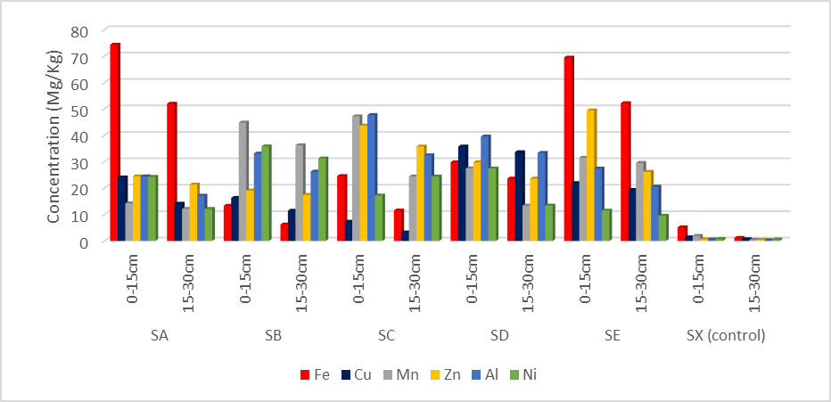
Figure 1: Level of metals found in soil from scrap metal dumpsite in Yenagoa metropolis, Bayelsa state, Nigeria.

The levels of pH and heavy metals in borehole water samples close to the scrap metal dumpsites in Yenagoa metropolis, Bayelsa state, Nigeria is presented in Figure 2. The concentration of iron, copper, manganese, zinc, aluminum and nickel ranged from 3.27 – 9.73 mg/l, 0.0152 – 0.071 mg/l, 0.0023 – 0.0023 mg/l, 0.0022 – 0.523 mg/l, 0.0023 -0.0023 mg/l and 0.005 – 0.005 mg/l respectively. The concentration for manganese, aluminum and nickel recorded shows that they were below detection limit, hence these metals were observed in the locations. The pH of the water ranged from 4.62 – 6.33 including the control.

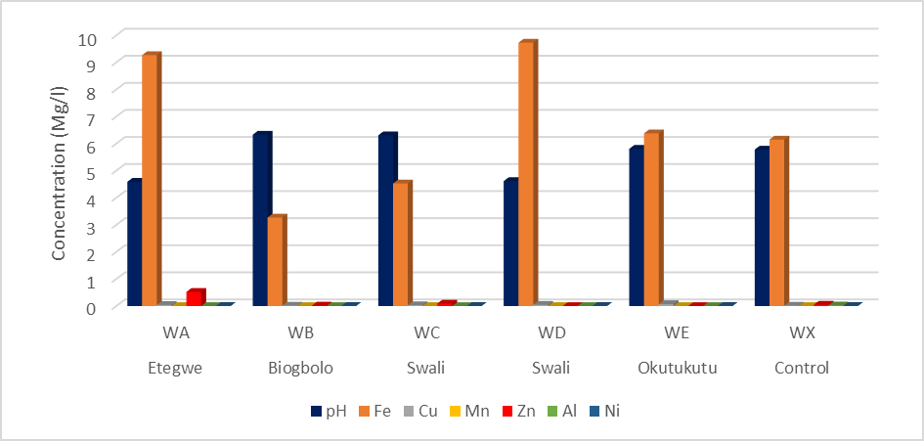
Figure 2: Heavy metals concentrations in borehole water samples close to the scrap metal dumpsites in Yenagoa metropolis, Bayelsa state, Nigeria.

The level of heavy metals found in the different vegetation from scrap metal dump site in Yenagoa metropolis, Bayelsa state, Nigeria is presented in Figure 3. Iron, copper and zinc concentration in the plants ranged from 0.338 – 3.027 mg/kg, 0.0152 – 0.1071 mg/kg and 0.0023 – 0.223 mg/kg respectively. Also, manganese, aluminum and nickel were not detected in the various vegetation samples.
Based on Figure 1, the concentrations of the heavy metals in the soil were generally higher in the top soil than in sub-soil. This is expected because the iron is deposited in the top soil directly. Again, it is on the top soil that all other activities of scrap metal dealers are been carried out. The difference in the heavy metals in the soil in the various dumpsites could be attributed to the duration that the metals have been in the area (dumpsite).

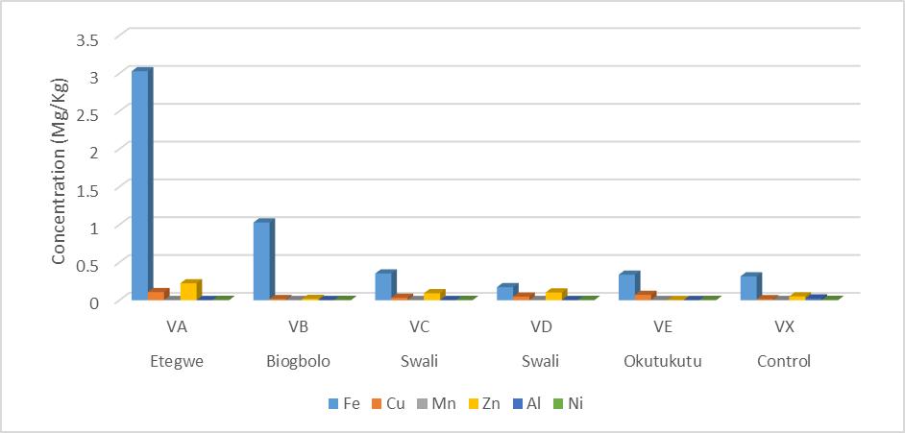
Figure 3: Level of heavy metals of vegetation samples from scrap metal dumpsites in Yenagoa metropolis, Bayelsa State, Nigeria.

Higher concentration of metals was observed in the dumpsites as when compared to the control. This suggests that heavy metal leaching into the soil could be altering the biochemical composition of the soil. The heavy metals were typically in the order; iron>Aluminum> Nickel> Zinc > Manganese > Copper. The higher concentration of iron in the soil could be attributed to attribute to the geologic formation of the area, which is rich in iron.
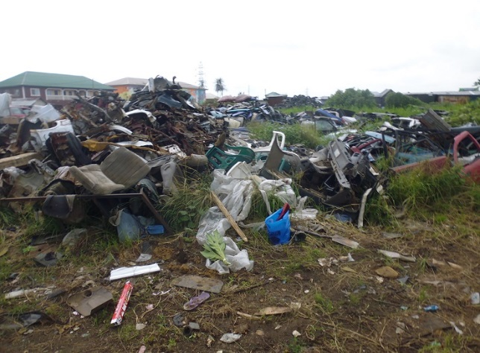
Figure 4: scrap metals generated from auto mechanic workshop in Yenagoa metropolis, Nigeria

High concentration of iron could adversely affects flora and fauna especially in water bodies [16]. High concentration of iron often manifest in the ground water. Typically, wastes in general often have adverse effects in the ecosystem. For instance, Umanu et al. [17], and Osu and Okereke [18] reported that wastes from automobile workshop discharged into the soil could have detrimental effects on the trophic chain and its biological compositions (i.e. microorganisms, vegetation, wildlife and humans). In automobile workshop scrap metals constitute a major part of wastes generated (Figure 4). Amos-Tautua et al. [10] reported that metals and organometallic contamination of soil constitute health hazards and soil deterioration especially for agricultural purposes. Nouri [19], also reported that the deposition of heavy metals in the soil could be deleterious to the soil productivity and ultimately to plants growth.
Authors have variously reported the concentration of heavy metals from different sources in Nigeria. Abidemi [16] studied the level of iron from automobile workshop soil in Osun state, Nigeria and reported the concentration of 262 – 43939 mg/kg. Elias and Gbadegesin [20] studied the concentration of heavy metals in soil from Lagos mainland area and reported mean concentration as 4.22 mg/kg (top soil) and 4.24 mg/kg (sub-soil) (iron), 2.09mg/kg (top soil) and 2.21 mg/kg (sub-soil) (copper), 7.38 mg/kg (top soil) and 7.34 mg/kg (sub-soil) (zinc). The authors reported the concentration of heavy metals in the soil in the order; zinc > Iron > Copper. Osu and Okereke [18] studied level of nickel in soil from automobile mechanic workshops, in port Harcourt metropolis, Rivers state, Nigeria and reported concentration at 4 soil depth including 0 – 5cm, 5 – 10cm, 10 – 20 cm and 20 – 30 cm as <0.001 – 0.710 mg/kg, <0.001 – 0.920 mg/kg, <0.001 – 0.723 mg/kg and <0.001 – 0.816 mg/kg respectively. Leke et al. [21] studied the concentration of heavy metals in soil of auto-mechanic shops and refuse dumpsite in Makurdi and reported mean level of copper and nickel in the range of 37.38 – 51.04 mg/kg and 4.20 – 48.62 mg/kg respectively.
From Figure 2, the heavy metals in ground water fluctuate between the control and the dumpsite for the metals such as iron, copper and zinc. Typically, apart from water sample from Etegwe and Swali, zinc concentration in the control is higher than other locations. Similarly, the control sample for iron is within the range of iron found in the borehole water samples from the different locations. The non-uniform pattern in the distribution of the heavy metals suggests that the water quality could not have been altered due to the activities of the dumpsite. This could be because the distance between the source of the borehole water and dumpsite is quite far, which ranged from 40 feet – 270 feet. The concentration of the heavy metals in the water samples are in the order of iron > Zinc > copper > Aluminum = Manganese = Nickel. Iron has been several reported from ground water in Yenagoa metropolis. For instance, Ohwo and Abotutu [22] reported the concentration of iron, zinc, and manganese from borehole water from Yenagoa metropolis in the range of 0.12 – 0.40mg/l, 0.15 – 0.78 mg/l and 0.01 – 0.30mg/l respectively. Ohimain et al. [23] similarly reported the concentration of iron, zinc and copper in the range of 5.32 – 9.96 mg/l, 0.01 – 0.96 mg/l and <0.01 mg/l respectively.
Nwankwoala et al. [24] also reported the level of iron, zinc, copper, nickel and manganese in groundwater in the range of 0.06 – 43.09 mg/l, 0.15 – 10.09 mg/l, 0.01 – 1.31 mg/l, 0.00 – 0.02 mg/l and 0.12 – 2.34 mg/l respectively. Amangabara and Ejenma, [25] reported some heavy metal concentration for both dry season as 0.007571 mg/l and wet season as 0.004 mg/l (zinc) and 0.5407 mg/l (wet season) and 0.967143 mg/l (dry season) (iron), 0.001 mg/l for both wet and dry season (copper) and 0.000286 mg/l (dry season) and 0.000mg/l (wet season) (manganese). Agbalagba et al. [26] also reported 0.40-1.40 mg/l and 0.00 mg/l as concentration of iron and copper found in ground water in Yenagoa metropolis, Bayelsa state, Nigeria. Okiongbo and Donglas [27] reported pH value of ground water in Yenagoa metropolis as 6.16.
Also the pH of the ground water is near the neutral limit of 6.5 – 8.5 recommended by SON/WHO for potable water sources, the findings of this study is comparable to previous reports from Yenagoa metropolis, Bayelsa state, Nigeria. Okiongbo and Donglas [27] reported pH of 6.16. Nkamare et al. [28] reported pH in groundwater as 6.97. Amangabara and Ejenma [25] reported pH of 6.027143 in dry season and 6.384286 in wet season, Ohimain et al. [23] reported pH of 4.39 – 5.17 (untreated ground water), 5.49 – 6.55 (single treated ground water) and 6.09 – 6.90 in double treated ground water. The concentration of heavy metals found in previous study indicates that these metals are found in the water. Therefore at the various concentration observed in this study indicate that the ground water is not affected by the activities of the scrap metals.
From Figure 3, the various concentrations of heavy metals that were detected in the various plant species from the dumpsites in Yenagoa metropolis, Nigeria, could be attributed to the age of the plants, plant parts that were assessed for the heavy metal concentration as well as the type of plant species. Also the heavy metal bioaccumulation could also depend on the phytoremediation potential to particular metals by the plant species. Some of the mechanisms through which plants remediate heavy metals from the environment include bioremediation, phytoextraction, phytovolatilization, phytostabilization, rhizofiltration, bio-absorption, phytoremediation e.t.c [29]. The study showed that the concentration of iron, copper and zinc is generally low. Basically high level of toxicity from heavy metal in biological system is associated to their high level of concentration in cells [30].
Furthermore, high toxicity could cause disorder and instability in the cell membrane resulting in dyfunctioning during photosynthesis, which could affect the mitochondrial electron transport and in the inactivation of several enzymes active sites, which may lead to decline in energy balance and disturbances in cell mineral nutrition [31]. Chaudri et al. [32], Broos et al. [33] and Dan et al. [34] reported that toxicity causes chlorosis, weak plant growth, yield depression, and low nutrient uptake and fixation of molecular nitrogen, disorders in plant metabolism etc. Again other authors have reported that heavy metals restricts metabolic activities causing toxicity to the plants in the form of decrease in seed germination, root and shoots growth and phytomass, chlorosis, photosynthesis, leading to stuntedness and death [35, 36].
Typically most of the metals detected in plant parts are essential metals (iron, copper and zinc). Copper is required for healthy growth of plants [37], probably due to the presence of co-factor for metalloproteins which helps in metabolic processes [37]. However, excess copper in plants is toxic due to its high redox potentials; therefore it could inhibit the growth of plants and changes its cellular properties [37]. Again, Nickel and Zinc are essential nutrient at low concentration but could be deleterious to plants at high level [38].
Zinc is a vital micronutrient required for several biochemical activities by plants [37] for it optimum productivity. Manganese is essential during photosynthesis, metabolism such as nitrogen and formation of other useful products/compounds need by plants.

4 Conclusions
Generally, from all monitored parameters, results indicates that, there was significant disparities of scrap metal impact on soil, water and vegetation quality in Yenagoa metropolis as opposed to the control samples. Notwithstanding, iron ranks highest amongst all heavy metals tested, while there was moderate, low and non-detected levels of other heavy metals. Results of the impact on vegetation also showed lesser contamination compared to soil and water quality. However the high and significant level of detected iron may not be largely attributed to scrap metal dumping activities but a characteristic of the Niger delta terrain. On the other hand, the moderate level of contaminants detected in the samples should not be taken for granted, as leachates originating from persistent dumping could migrate to groundwater through infiltration.

References
- Hosetti, B. B. (2006). Prospects and perspectives of solid waste management, New Age International Publishers. New – Delhi India.
- George K. S., Opku I. (2009). Urban solid waste management .A case study of waste Disposal in Yenagoa metropolis Bayelsa State.
- Ekweozor, N. E. (2006). Solid waste management in Developing Countries. A case study of waste management in Enugu metropolis Enugu State.
- Schwarz-Herion, O., Omran, A., Rapp. H. P. (2008). A case study on successful municipal solid waste management in industrialized countries by the Example of Karlsruhe city, Germany. Journal of Engineering Annals, of the Faculty Engineering Hunetoara. 6(3), 266-273.
- Angaye, T. C. N., Zige, D. V., Izah, S. C. (2015). Microbial Load and Heavy Metal properties of Leachate from solid waste dumpsite in the Niger Delta, Nigeria, Journal of Environmental treatment Techniques. 3(5), 71-75.
- Olanrewaju, O. O., Ilemobade, A. A. (2009). Waste to wealth: A case study of the Ondo State Integrated Wastes recycling and treatment projects, Nigeria, European Journal of Social Sciences, 8(1), 7-16.
- Ayotamuno, J. M., Gobo, A. E. (2004). Municipal solid waste management in Port Harcourt, Nigeria. Management of Environmental Quality: An International Journal, 15(4), 389-398.
- Nabegu AB (2010). An analysis of municipal solid waste in Kano metropolis, Nigeria. J. Hum. Ecol. 31(2), 111-119.
- Odu, C. T. L. (2001). Waste Management in Bayelsa State: Problem and Prospects. Seminar pepper presented at Nigerian Environment Society Inauguration of Bayelsa Chapter in Yenagoa.
- Amos-Tautua, B. M. W., Onigbinde, A. O., Ere, D. (2014). Assessment of some heavy metals and physicochemical properties in surface soils of municipal open waste dumpsite in Yenagoa, Nigeria. African Journal of Environmental Science and Technology, 8(1), 41-47.
- Izonfuo, L. W. A., Bariweni, A. P. (2001). The effect of urban runoff water and human activities on some physico- chemical parameters of the Epie Creek in the Niger Delta. Journal of Applied Science and Environmental Management, 5(1), 47-55.
- Ogwueleka, T. C. (2004). Planning model for refuse management. Journal of Science and Technology, 3(2) , 71-76.
- Nkwachukwu, O. L., Chidi, N. I, Kano, O. C. (2010). Issues of Roadside Disposal habit of Municipal solid waste, Environmental Impacts and implementation of sound management. Policies, in Developing country “Nigeria. International journal of Environmental Science and Development. 1(5), 409-418.
- N P C (2006). National Population Commissions, 2006 Census of Nigeria.
- Ademoroti, C.M.A. (2006). Standard Method for Water & Effluents Analysis. 1st Edition. Foludex press limited, Ibadan, Nigeria.
- Abidemi, O.O. (2011). Levels of Pb, Fe, Cd and Co in Soils of Automobile Workshop in Osun State, Nigeria. Journal of Applied Sciences and Environmental Management, 15(2), 279-282
- Umanu, G., Akpe, A. R., Omoikhudu, A. R., (2013). Oil degradation assessment of bacteria isolated from used motor oil contaminated soils in Ota, Nigeria. International Journal of Advanced Biological Research, 3(4), 506-513.
- Osu, C. I., Okereke, V. C. (2010). Heavy Metals Contamination in Relation to Microbial Counts in Soils of Automobile Mechanic Workshops, Port Harcourt Metropolis, Rivers States, Nigeria, Journal of American Science, 6(9), 236-241.
- Nouri, J., Peterson, P. J., Alloway, J. B. (2001). Effect of variation in harvest time on the uptake of metals by barley plants from soil amended with sludge and compost. J. Biol. Sci., 1, 1056-1059.
- Elias P., Gbadegesin A. (2011). Spatial Relationships of Urban Land Use, Soils and Heavy Metal Concentrations in Lagos Mainland Area. Journal of Applied Sciences and Environmental Management, 15(2), 391–399.
- Leke, L., Akaahan, T. J., Simon A. (2011). Heavy Metals in Soils of auto- mechanic shops and refuse dumpsites in Makurdi Nigeria. Journal of Applied Sciences and Environmental Management, 15(1), 207-210.
- Ohwo, O., Abotutu, A. (2014). Access to potable water supply in Nigerian cities evidence from Yenagoa Metropolis. Amer J Water Resources, 2(2), 31-36.
- Ohimain E. I., Angaye T. C. N., Okiongbo, K. S. (2013). Removal of iron, coliforms and acidity from ground water obtained from shallow aquifer using trickling filter method. J Environ Sci Eng, A2, 349-355.
- Nwankwoala, H. O., Udom, G. J, Ugwu, S. A. (2011). Some heavy metal investigations in groundwater sources in Yenagoa, Bayelsa state, Nigeria. J Appl Technol Environ Sanitation, 1(2), 163-170.
- Amangabara, G.T., Ejenma, E. (2012). Groundwater Quality Assessment of Yenagoa and Environs Bayelsa State, Nigeria between 2010 and 2011. Resources and Environment, 2(2), 20-29.
- Agbalagba, O. E., Agbalagba, O. H., Ononugbo, C. P., Alao, A. A. (2011). Investigation into the physico-chemical properties and hydrochemical processes of groundwater from commercial boreholes In Yenagoa, Bayelsa State, Nigeria. Afr J Environ Sci Technol. 5(7), 473-481.
- Okiongbo, K. S, Douglas, R. (2013). Hydrogeochemical analysis and evaluation of groundwater quality in Yenagoa city and environs, southern Nigeria. Ife Journal of Science, 15(2), 209-222.
- Nkamare, M. B., Ofili, A. N., Adeleke, A. J. (2012). Physico-chemical and microbiological assessment of borehole water in Okutukutu, Bayelsa State, Nigeria, Advances in Applied Science Research, 3(5), 2549-2552.
- Yang, X. E., Peng, H. Y., Jiang, L. Y. (2005). Phytoremediation of Copper from contaminated soil by Elsholtzia splendens as affected by EDTA, citric acid and compost. International Journal of Phytoremediation, (7), 69-83.
- Jadia, D., Fulekar, M. H. (2008). Phytotoxicity and Remediation of Heavy Metals by Alfalfa (Medicago sativa) in Soil-vermicompost Media. Advances in Natural and Applied Sciences, 2(3), 141-151.
- Gondek, K., Filipek-Mazur B. (2003). Biomass yields of shoots and roots of plants cultivated in soil amended by vermicomposts based on tannery sludge and content of heavy metals in plant issues, Soil Environ, 49(9), 402-409.
- Chaudri, A. M., Allain, C. M, Barbosa-Jefferson, V. L., Nicholson F. A., Chambers, B. J., McGrath S. P. (2000). A study of the impacts of Zn and Cu on two rhizobial species in soils of a long term field experiment, Plant Soil, 22, 167-179.
- Broos, K., Beyens H., Smolders E. (2005). Survival of rhizobia in soil is sensitive to elevated zinc in the absence of the host plant, Soil Biol. Biochem, 37, 573 - 579.
- Dan T., Hale B., Johnson D., Conard B., Stiebel B., Veska E. (2008). Toxicity thresholds for oat (Avena sativa L.) grown in Ni-impacted agricultural soils near Port Colborne, Ontario, Canada. Can. J. Soil Sci, 88, 389-398.
- Gardea-Torresdey, J. L., Tiemann, K. J., Gamez, G., Dokken, K., Cano-Aguilera, I. M., Renner M. W, Furenlid, L. R (2000). Reduction and accumulation of gold (III) by Medicago sativa alfalfa biomass: X-ray Absorption Spectroscopy, pH and temperature dependence, Environ. Sci. Technol., (34), 4392-4396.
- Roy S. et al. (2005). Phytoremediation of heavy Metal and PAH-contaminated brownfield sites. Plant and soil, 272, 277–290.
- Kumar, V. N., Ashwani, K. (2013). A Comparative study of heavy metals in Emblica officinalis, Phyllanthus emblica and Azadirachta indica. International Research Journal of Biological Sciences, 2(8), 16-19.
- Lester, G. (1997). Fruit nutritional quality and health functionality, Cucumus melo L, 7, 222-227.

Corresponding author: Tariwari C .N., Ecotoxicology Research Unit, Department of Biological Sciences, Niger Delta University, Wilberforce Island, Bayelsa State, Nigeria. E-mail: maktarry@yahoo.com

